***ROJECT REPORT TEMPLATE***

***1. INTRODUCTION***

***1.1 Overview***

Tableau is a most POWERFUL DATA VISUALIZATION.

**1.2 *Purpose :***

It helps users create different Charts, Graphs, Maps, Dashboard and Stories for Visualizating and Analyzing data.

***2.PROBLEM DEFINATION AND***

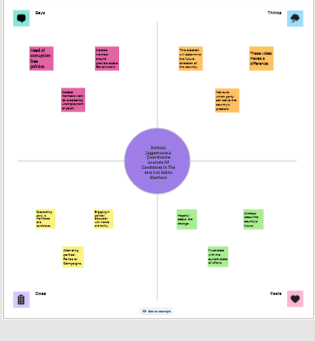

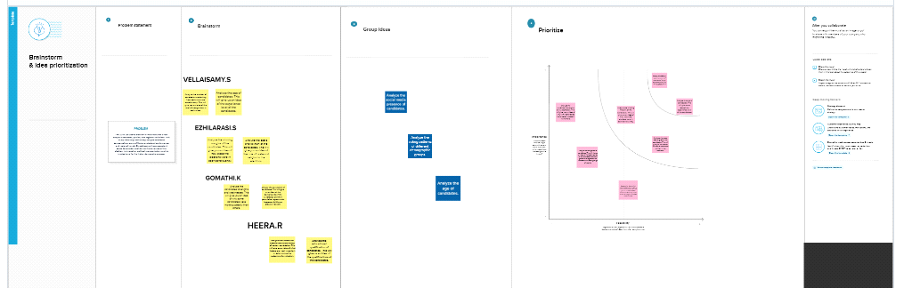

***3. RESULT :***

Final findings (out put) of the project along with Screenshot.

***4. ADVANTAGES :***

1. .Excellent Mobile support.

2. Its creact the leavelasting impact in future.

3. Gain critical data skills to prepare you for a digital data-deiven future.

4. Easy to upgrade.

5. Set yur self up against the Compitition.

6. Lanel your Dream job.

***5. DISADVANTAGES :***

1**.** Its too Expensive for some users.

2. Its knowledge skill required.

3. It can Handle an Incredible amount of data.

4. No version control.

5. Requires SOL knowledge.

***6. APPLICATION :***

1. You can easily builed.

2. Interate on visualizations with a drag and drop experince and dynamic previws.

3. Profit margin analysis.

***7. CONCLUSION :***

***1.*** We covered different ways to create calculated fields in Tableau.

2. We can create dashboards very easily and within less time.

3. Though the data set is complen or the dataset is very big in Tableau.

***8. FUTURE SCOPS :***

1. It is just a tool used in business analysis.

2. Tableau is not a language or a platform.

3. One of the most popular tools in business intelligence (B1).